Global cropland map processing

Contents

[1. Creating Cropland probability map 4](#_Toc319409572)

[1.1. Parameters for Map 07032012\_3 4](#_Toc319409573)

[1.2. Parameters for Map 07032012\_4 (07032012\_2) 8](#_Toc319409574)

[1.3. Parameters for Map 08032012\_1 11](#_Toc319409575)

[2. Creating Global Cropland Map 13](#_Toc319409576)

[2.1. Parameters for Map 07032012\_3 (Average Cropland Map) 13](#_Toc319409577)

[2.2. Parameters for Map 07032012\_3max (Maximum Cropland Map) 15](#_Toc319409578)

[2.3. Parameters for Map 07032012\_4 (Average Cropland Map) 17](#_Toc319409579)

[2.4. Parameters for Map 07032012\_4max (Maximum Cropland Map) 19](#_Toc319409580)

[2.5. Parameters for Map 08032012\_1 21](#_Toc319409581)

[3. Difference between the maps 23](#_Toc319409582)

[3.1. Processing steps 23](#_Toc319409583)

[3.2. Output Maps 23](#_Toc319409584)

# Creating Cropland probability Layer Map

First step in the creation of a global cropland map is the creation of the cropland probability layer map. This is done using the Cropland Probability Layer Tool. The tool calculates the probability statistics and shows how likely it is that there is cropland within the pixel cell. The higher the class numbers the higher the probability.

The following input files are needed:

Area Grid: area\_grid.img

Country Grid glob\_stat\_l).img

Input Cropland Grids: prod\_avg\_regional\_120306\_F2.img

prod\_avg\_geocover.img

prod\_avg\_africa\_jrc.img

prod\_avg\_modis.img

prod\_avg\_glc.img

prod\_avg\_glo.img

prod\_avg\_hansen.img

However, the input maps have to be prioritized, according to their quality. The highest priority equals highest number.

The different output maps that are generated include:

* Probability map
* Max percentage layer
* Min percentage layer
* Average percentage map

All maps serve as input for the second step, Cropland validator. However, the minimum percentage layer is not used in the second step of this analysis.

## Parameters for Map 07032012\_3

**Input rater ranking:**

1. - prod\_avg\_regional\_120306\_F2.img

2. - prod\_avg\_geocover.img

3. - prod\_avg\_africa\_jrc.img

4. - prod\_avg\_modis.img

5. - prod\_avg\_glc.img

6. - prod\_avg\_glo.img

7. - prod\_avg\_hansen.img

**Priority settings:**

Priority values 1: [2, 1, 1, 1, 1, 1, 1]

Priority values 2: [7, 6, 5, 4, 3, 2, 1]

**Output Maps:**

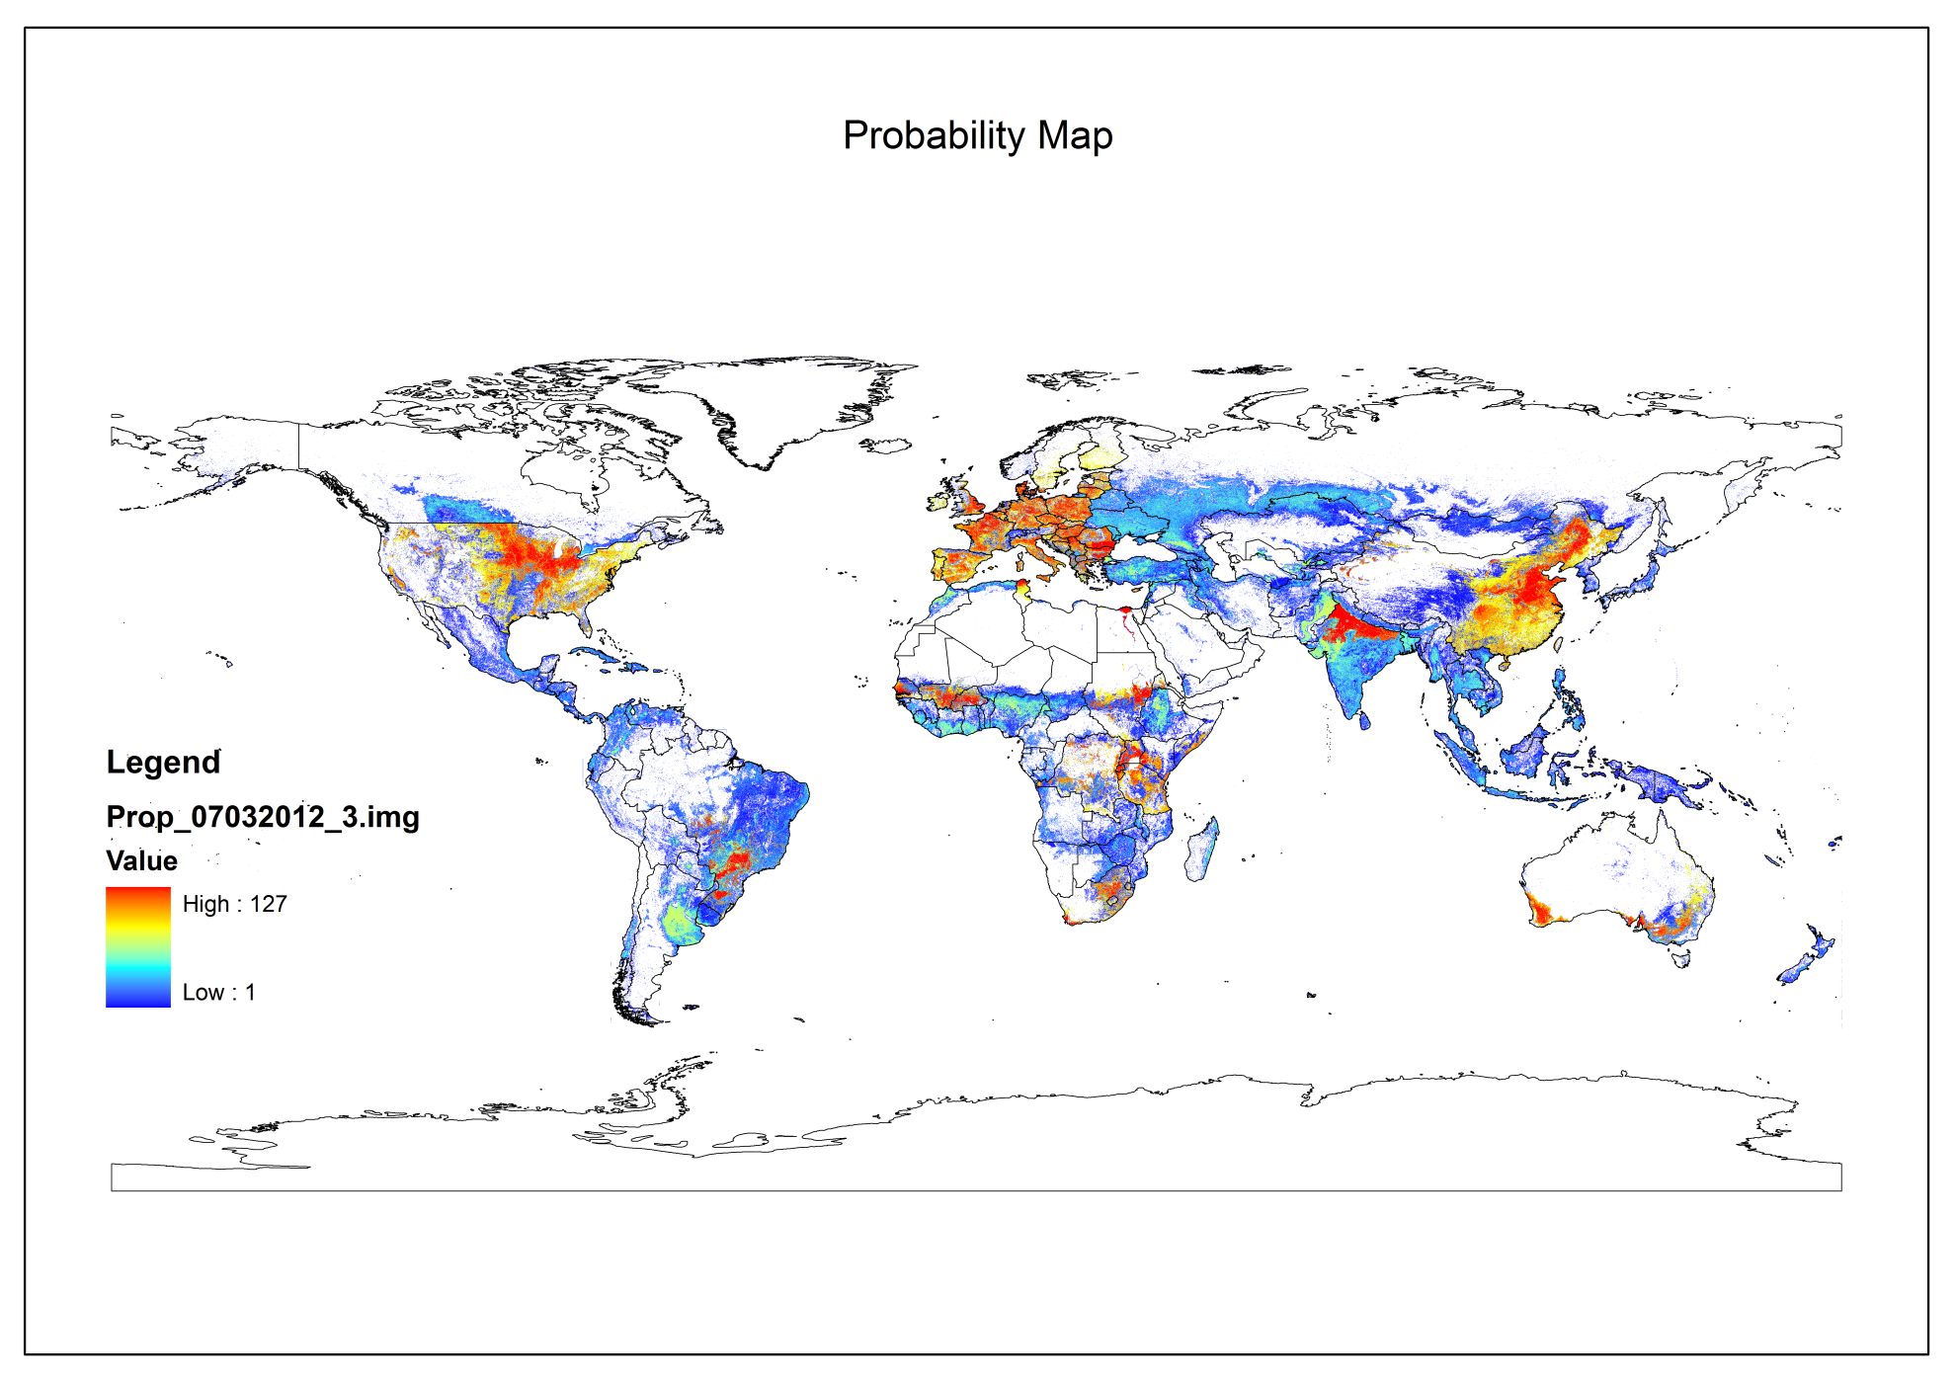

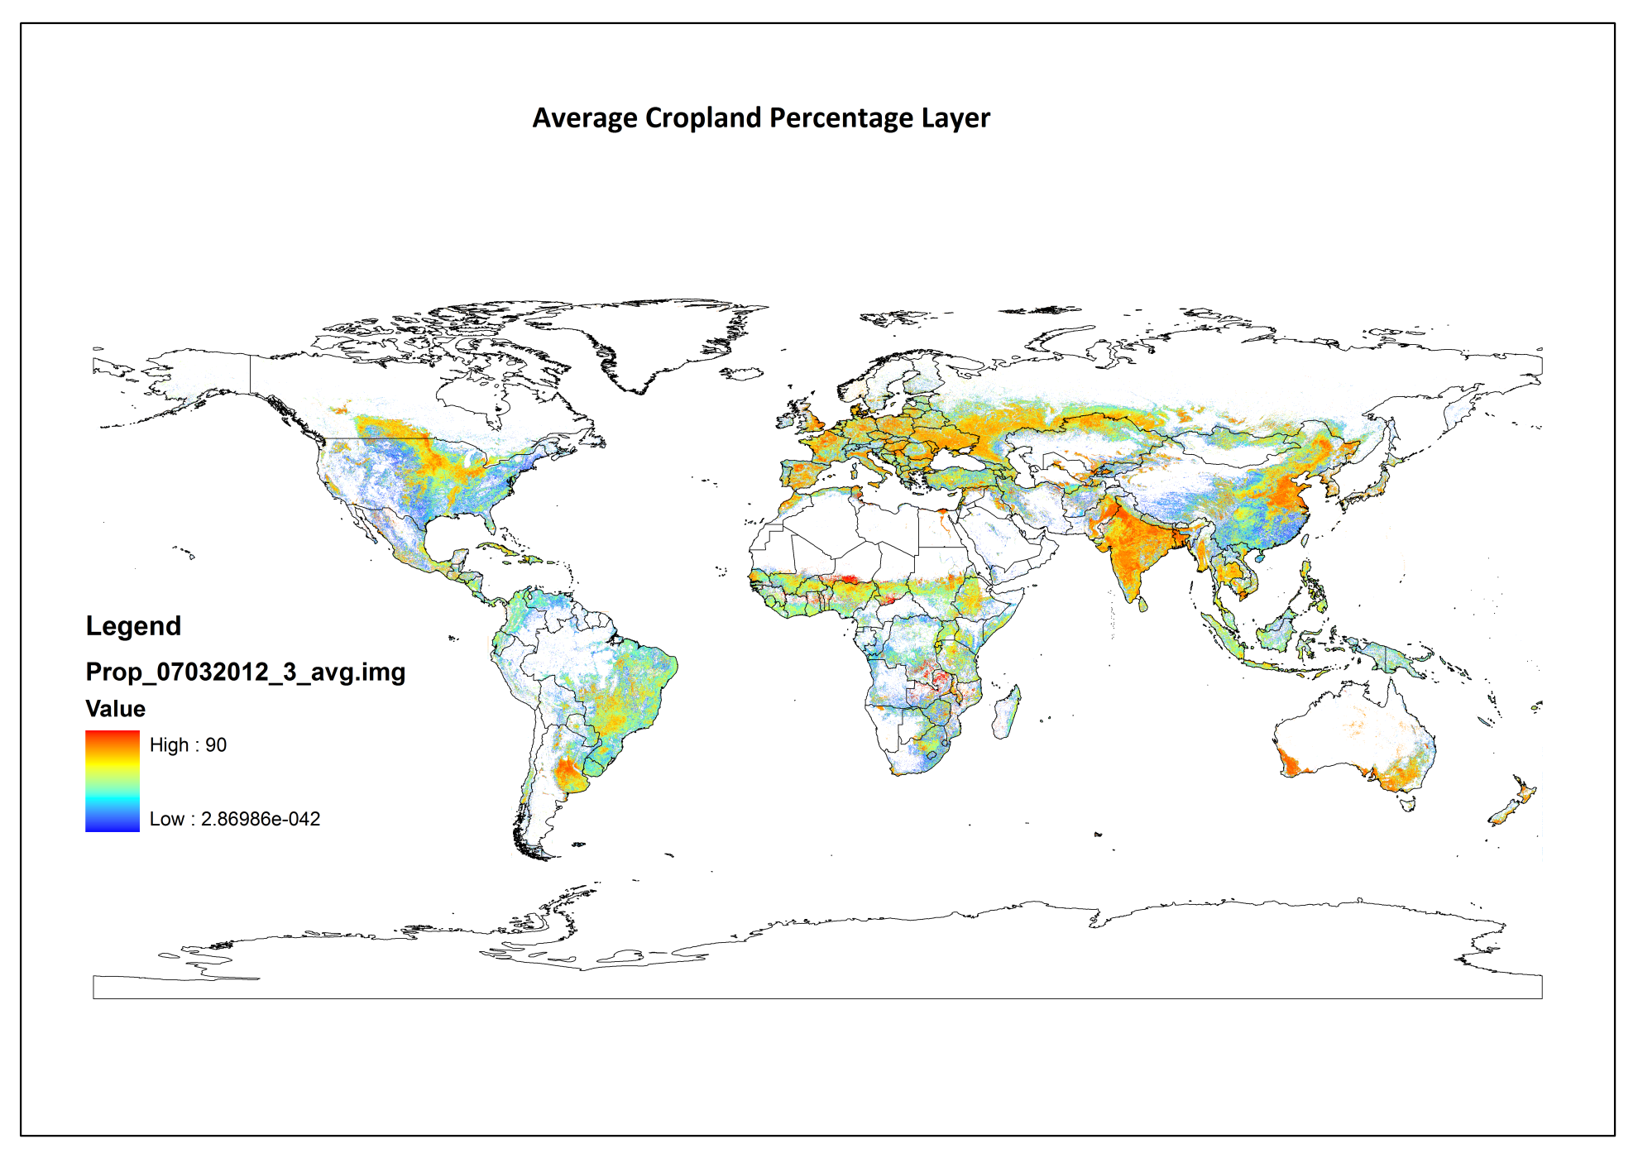

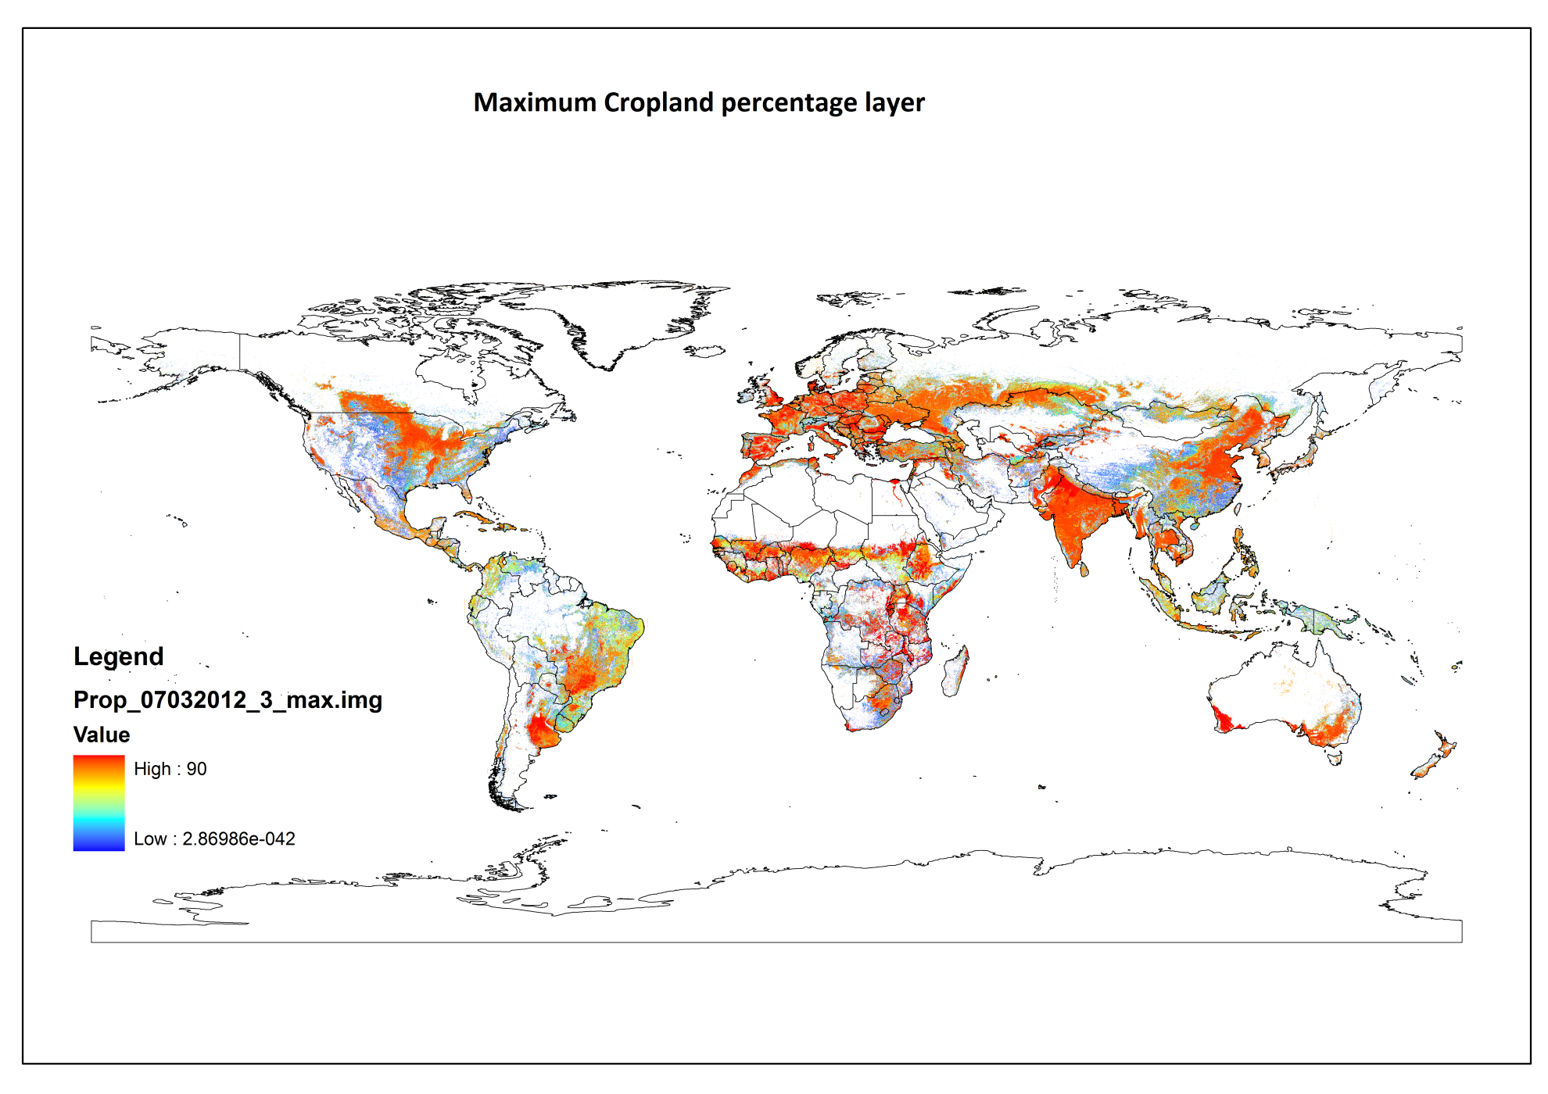

## Parameters for Map 07032012\_4 (07032012\_2)

**Input raster ranking:**

1. - prod\_avg\_regional\_120306\_F2.img

2. - prod\_avg\_geocover.img

3. - prod\_avg\_africa\_jrc.img

4. - prod\_avg\_glc.img

5. - prod\_avg\_modis.img

6. - prod\_avg\_glo.img

7. - prod\_avg\_hansen.img

**Priority settings:**

Priority values 1: [2, 1, 1, 1, 1, 1, 1]

Priority values 2: [7, 6, 5, 4, 3, 2, 1]

**Output Map:**

**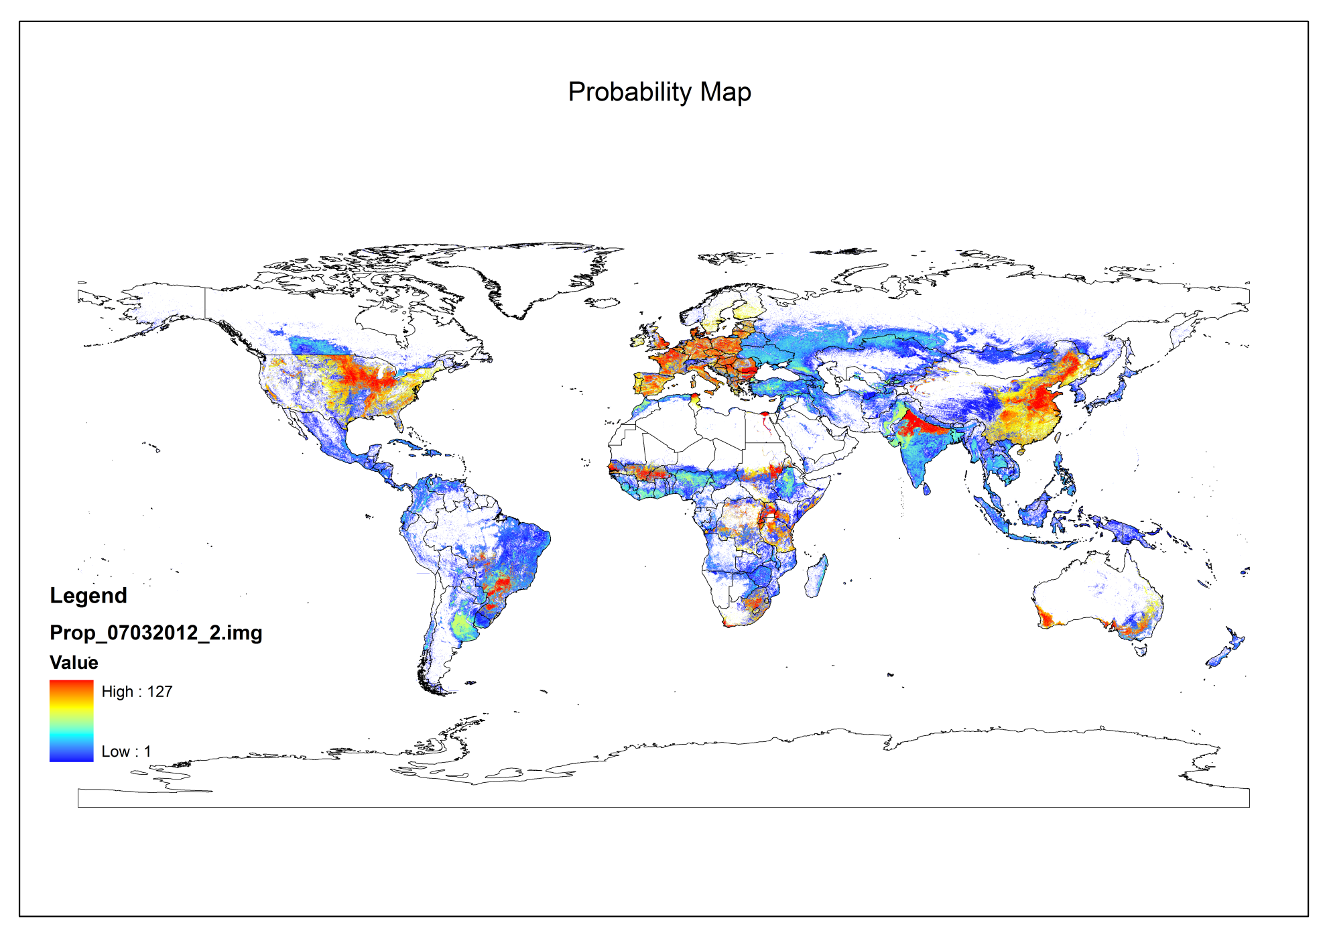** **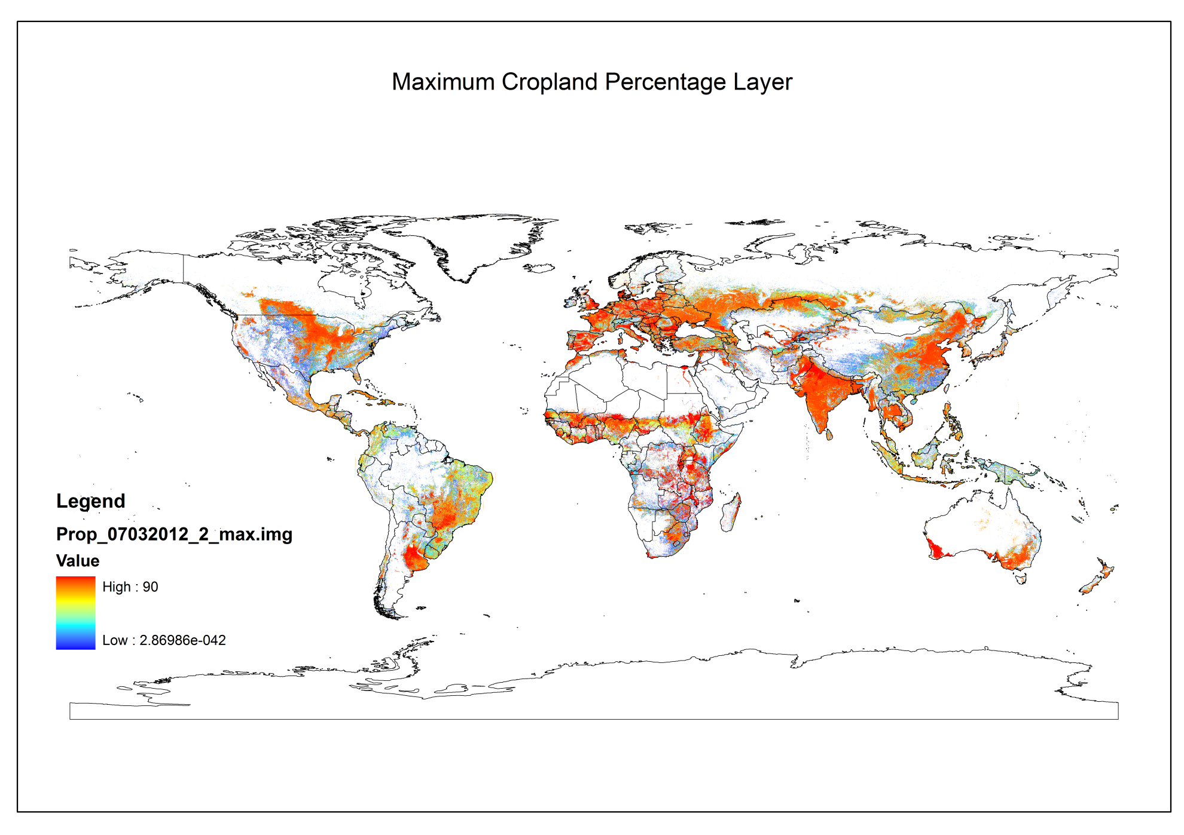**

## Parameters for Map 08032012\_1

**Input raster ranking:**

1. - prod\_avg\_regional\_120306\_F2.img

2. - prod\_avg\_geocover.img

3. - prod\_avg\_africa\_jrc.img

4. - prod\_avg\_modis.img

5. - prod\_avg\_glc.img

6. - prod\_avg\_glo.img

7. - prod\_avg\_hansen.img

**Priority settings:**

Priority values 1: [2, 1, 1, 1, 1, 1, 1]

Priority values 2: [6, 5, 5, 4, 3, 2, 1]

**Output Map:**

**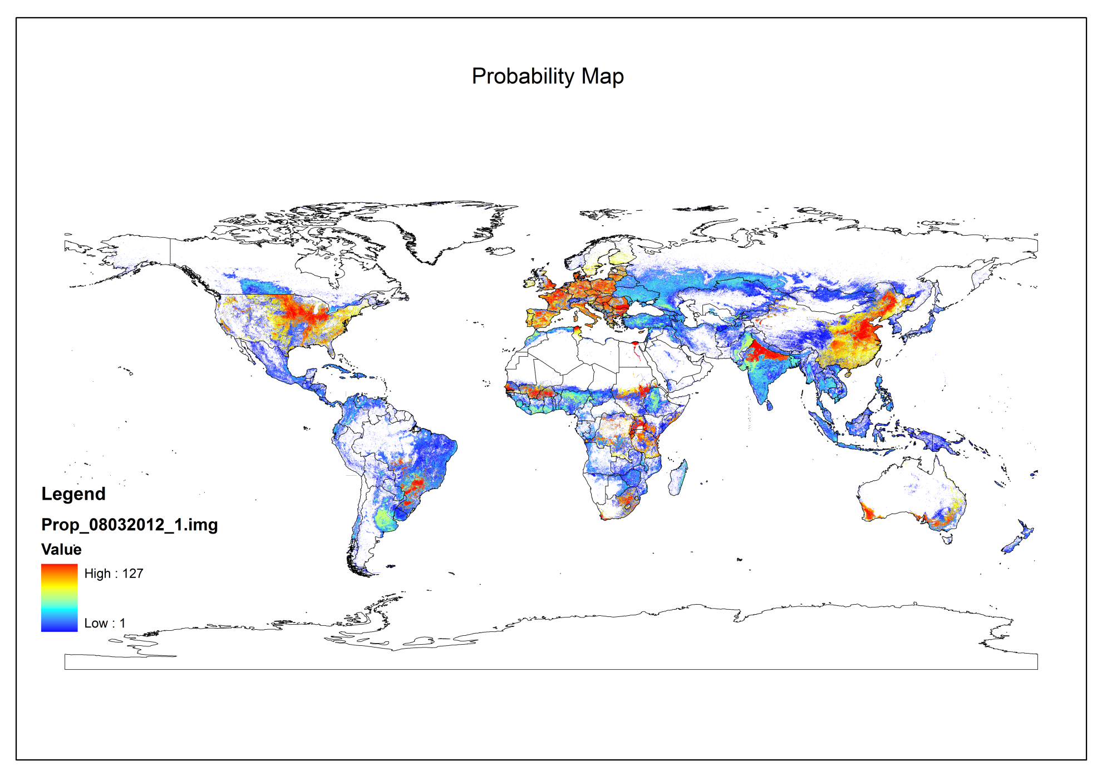**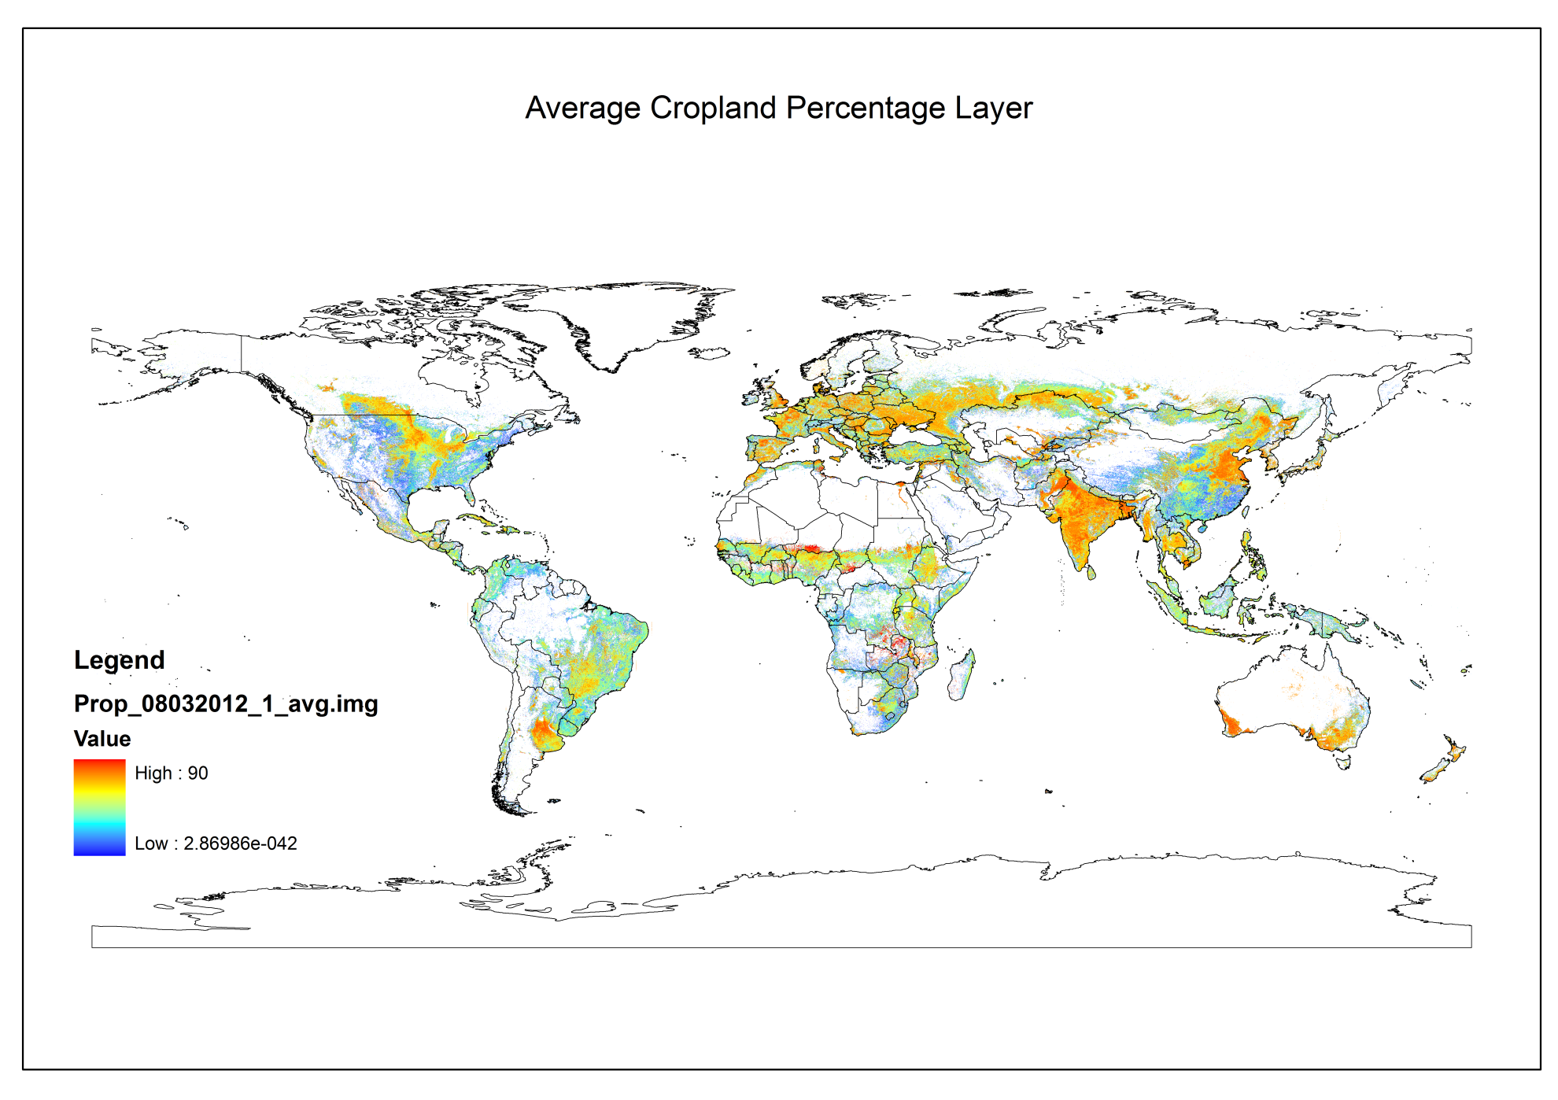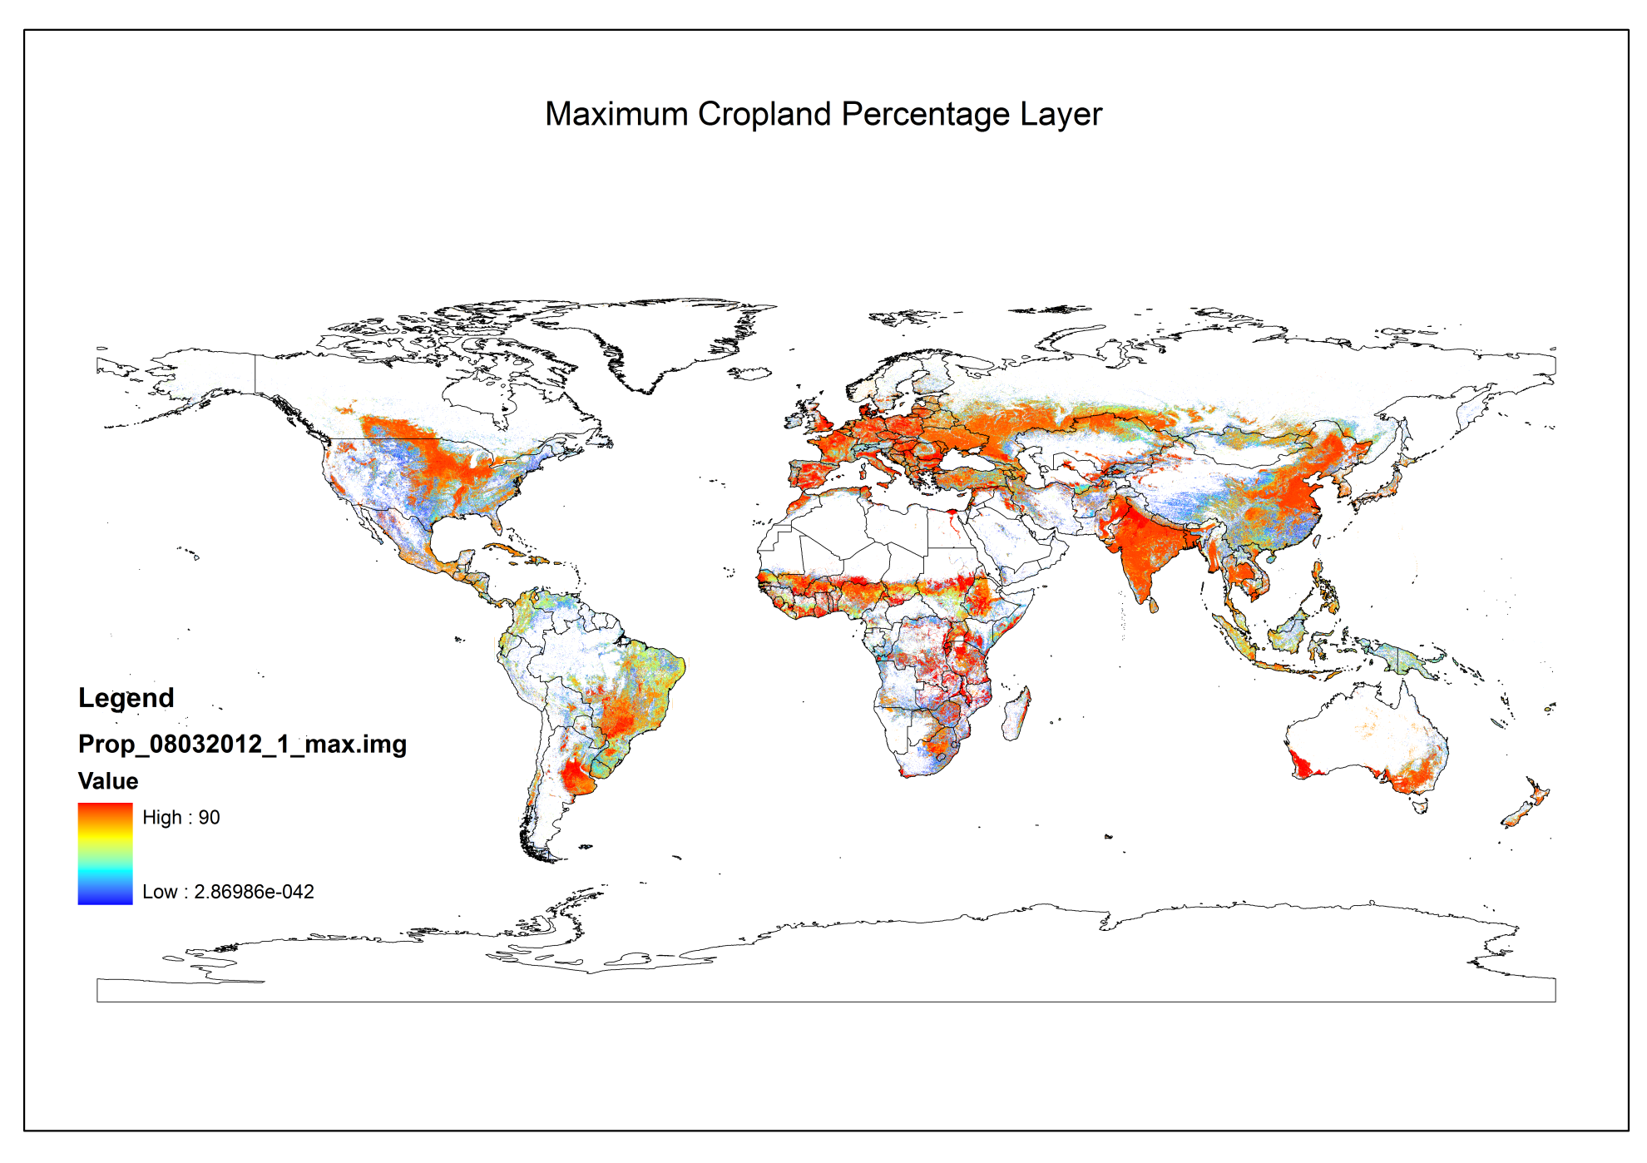

# Creating Global Cropland Map

The second step is done using the Cropland Validator Tool. The cropland validator tool creates the final product**: A calibrated cropland map.**

The following input files are needed:

Area grid: area\_grid.img

Level 0 statistics: glob\_stat\_I0.img

Level 1 statistics: glob\_stat\_I1.img

Level 2 statistics: glob\_stat\_I2.img

**Probability map: defined for respective output map**

**Min/average/max percentage layer: defined for respective output map**

## Parameters for Map 07032012\_3 (Average Cropland Map)

**Input Parameters:**

Area grid, level 0 to 2 statistics stay the same.

Parameters that change are:

**Probability map:** Probability Map for 07032012\_3

**Min/average/max percentage layer: *Average*** *Probability Percentage* Map

**Output Map:**

**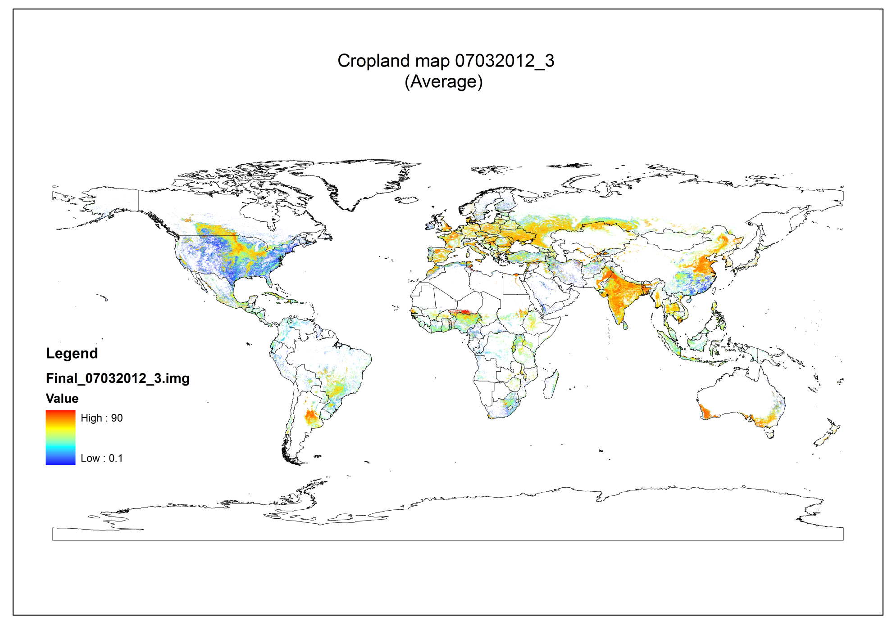**

## Parameters for Map 07032012\_3max (Maximum Cropland Map)

**Input Parameters:**

Area grid, level 0 to 2 statistics stay the same.

Parameters that change are:

**Probability map:** Probability Map for 07032012\_3

**Min/average/max percentage layer: *Maximum*** *Probability Percentage* Map

**Output Map:**

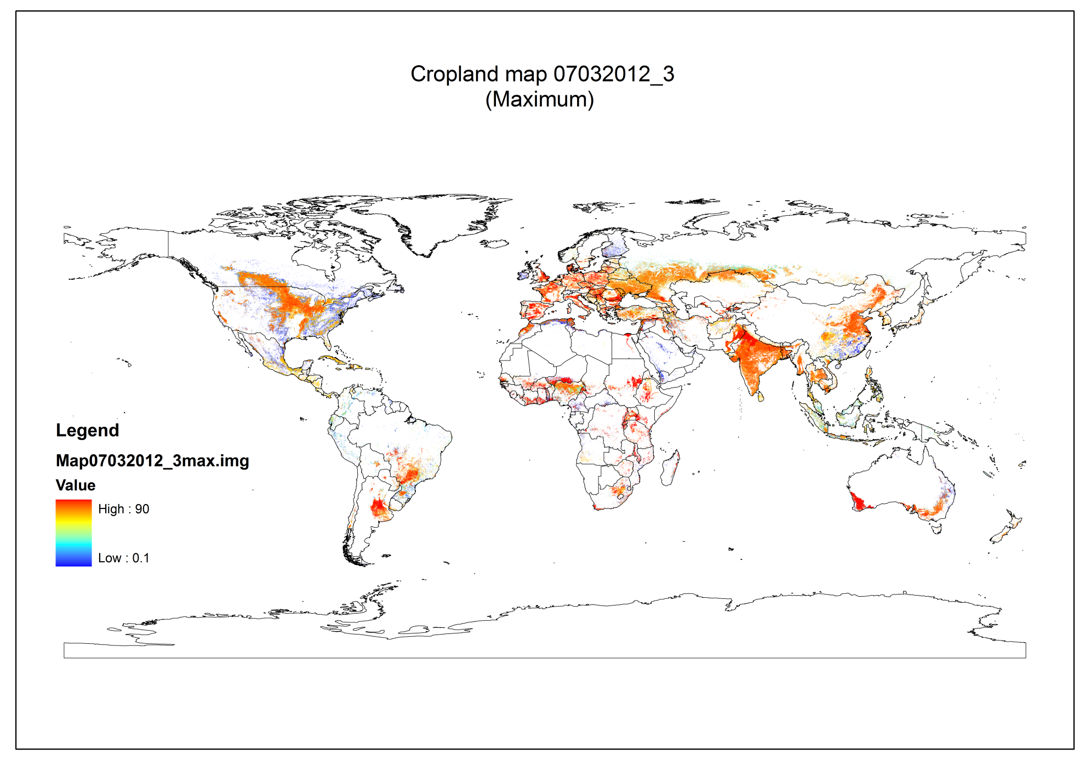

## Parameters for Map 07032012\_4 (Average Cropland Map)

**Input Parameters:**

Area grid, level 0 to 2 statistics stay the same.

Parameters that change are:

**Probability map:** Probability Map for 07032012\_4

**Min/average/max percentage layer: *Average*** *Probability Percentage* Map

**Output Map:**

**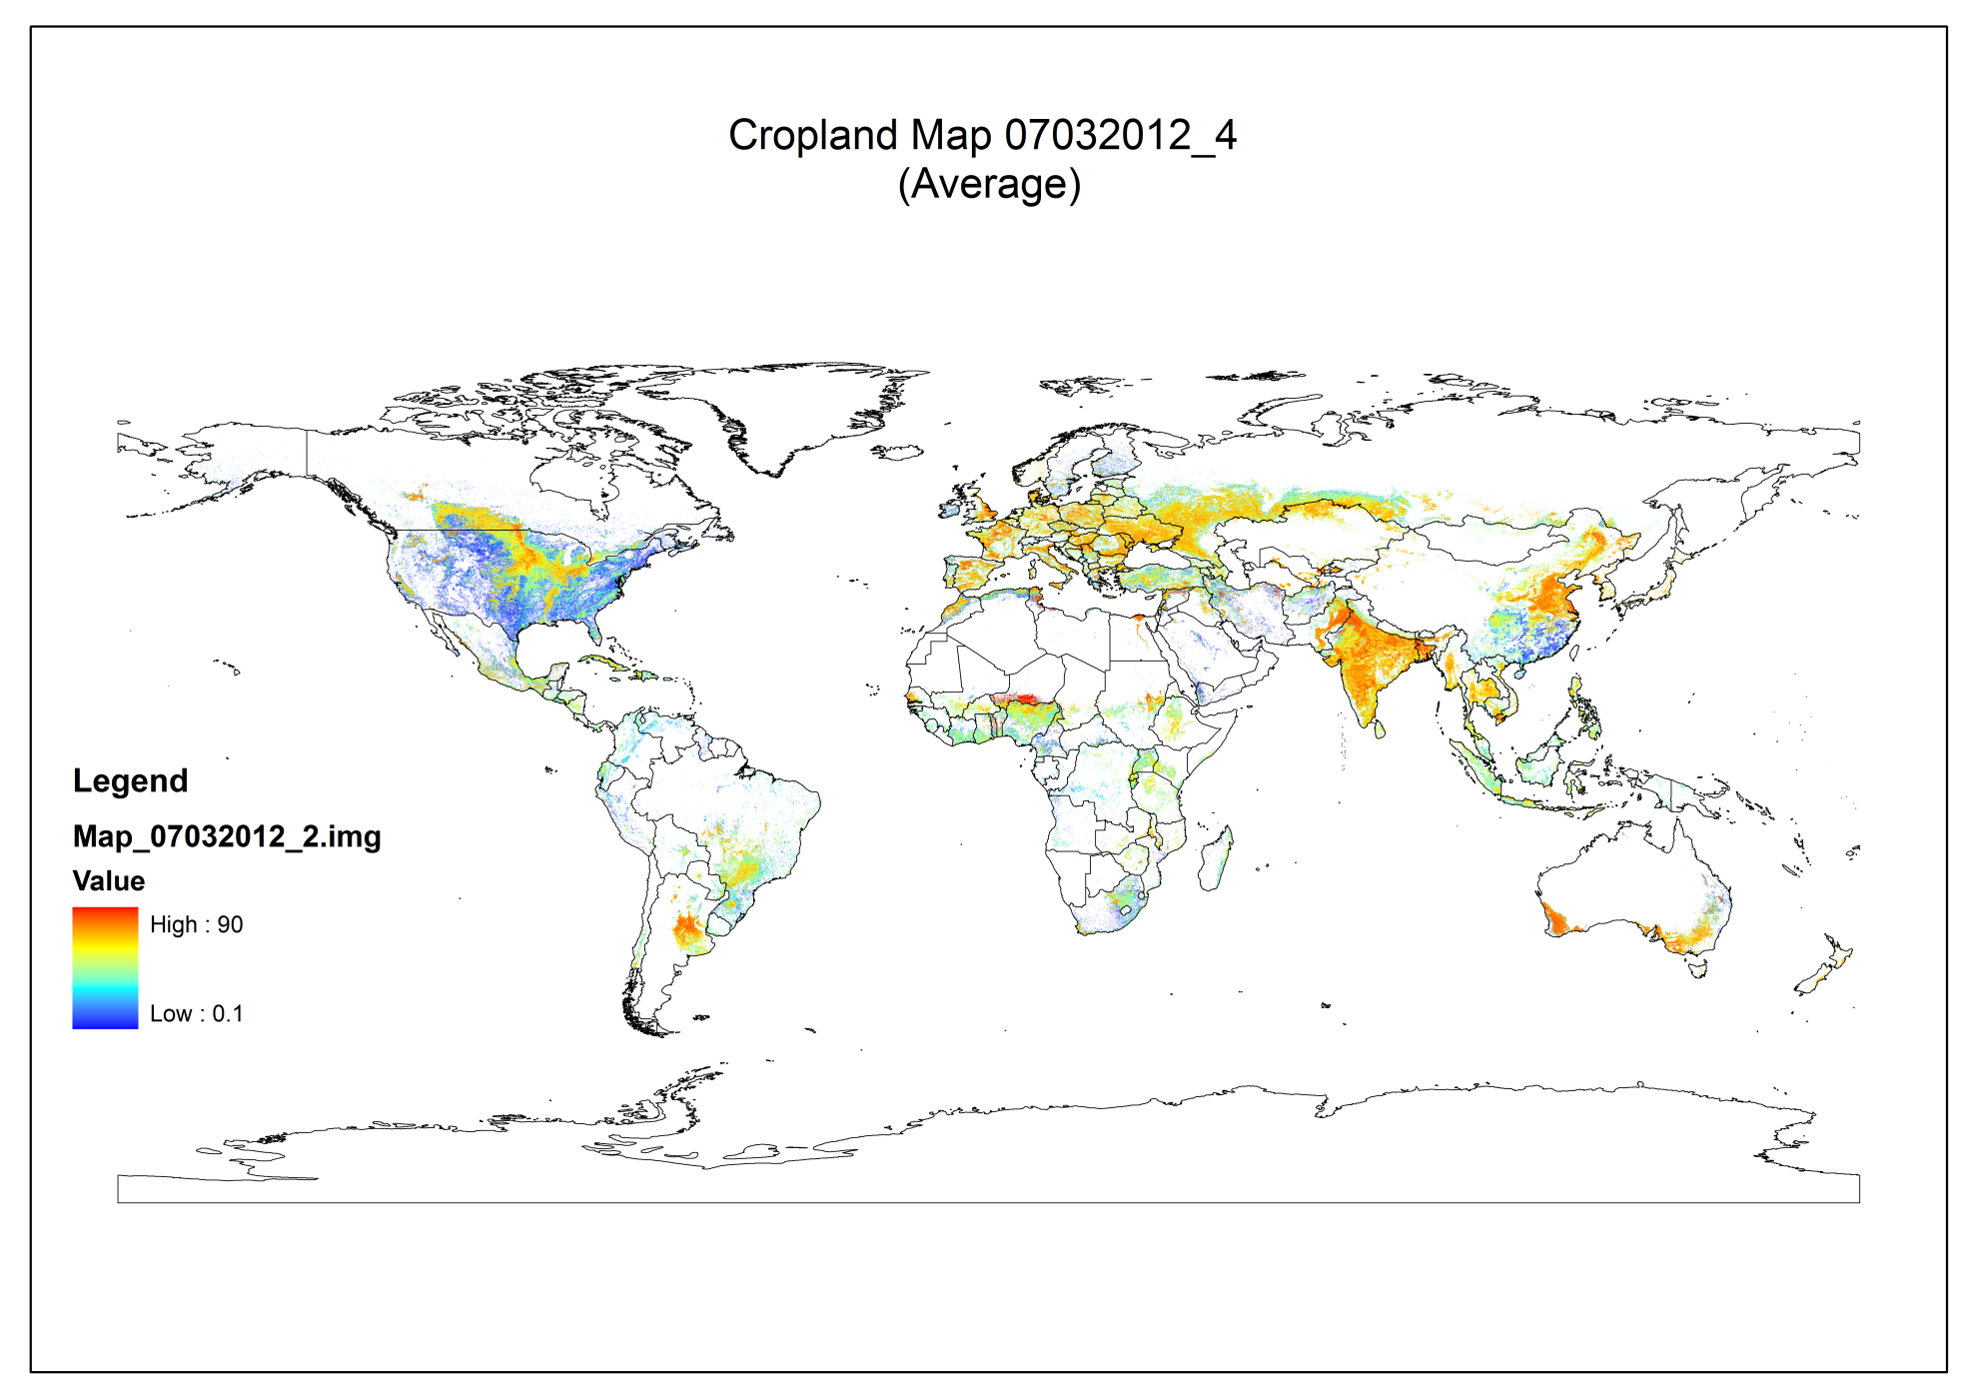**

## Parameters for Map 07032012\_4max (Maximum Cropland Map)

**Input Parameters:**

Area grid, level 0 to 2 statistics stay the same.

Parameters that change are:

**Probability map:** Probability Map for 07032012\_4

**Min/average/max percentage layer: *Maximum*** *Probability Percentage* Map

**Output Map:**

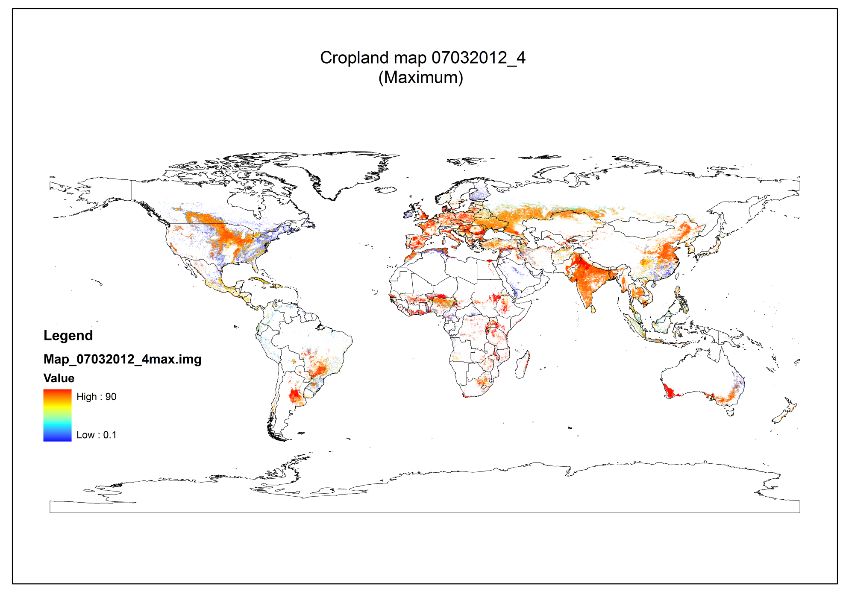

## Parameters for Map 08032012\_1

**Input Parameters:**

Area grid, level 0 to 2 statistics stay the same.

Parameters that change are:

**Probability map:** Probability Map for 08032012\_1

**Min/average/max percentage layer: *Average*** *Probability Percentage* Map

**Output Map:**

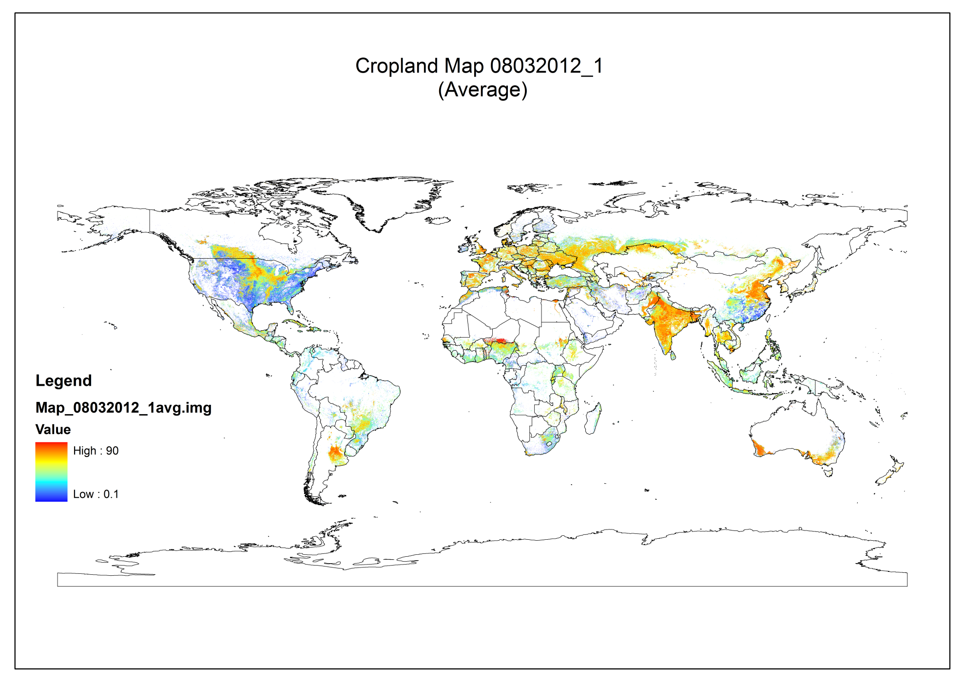

# Difference between the maps

## Processing steps

1. Reclassification of the final cropland map into two groups, with 1 being cropland and 0 being non cropland.
2. Subtracting the maps to see the area difference.

Both steps are done for average cropland maps and maximum cropland maps.

## Output Maps:

## 

## C:\Users\albrecht\Desktop\Steffen\Difference\MAp4_3.pngC:\Users\albrecht\Desktop\Steffen\Difference\MAp4_3_MAX.png